Proposal for Mobile Health Service

Name
Professor
Date

Proposal for Mobile Health Service
The modern-day world is characterized by immense changes that are taken place on all fronts and especially in the Health sector. These changes have been made possible through extensive adoption of technology in almost all fields and the impact of this technological revolution does not make it easy for the global population as most are left to play catchup with negative implications on their organizations and institutions given the loss of competitive advantages where the acquisition of state of the art equipment that make productions more effective is concerned. The health sector has not been left behind either. There are numerous technologies being introduced daily into the health care delivery systems to help with the diagnosis and management of diseases. The incorporation of diverse computerizedequipment in the routine work place is slowly replacing old technology and practices and this is especially true for the record keeping and radiology departments. In the spirit of helping to manage patient data more effectively and to enhance communication between the healthcare professionals which is postulated to subsequently improve the collaboration between the various healthcare professionals and hence improve on the quality of care being offered to the patients (Alotaibi & Federico, 2017), the manual health records systems have slowly but effectively been replaced by the more efficient universal electronic Health Management Systems (Alotaibi & Federico, 2017). In terms of imaging, the sole role of the radiology department, the institution of computerized scanning machinery such as the Positron Emission Tomography (PET) scan have substantially replaced the use of old radiological texts such as the X Rays (Bercovich & Javitt, 2018).
Despite the fact that technology is helping the health sector to improve on its service delivery systems and on the efficiency and quality of the managements being offered to patients, the advent of extensive use of technology in this sector substantially contributes to the increase in healthcare associated costs (Kumar, 2011). This draws solely from the increasing dependence on medical technology, the costs of which are ever increasing as the major contributing factor to the spiraling healthcare costs (Kumar, 2011). Despite their being services such health insurance services and programs or acts such as the Obama Care that have substantially helped the majority of the population to have access to healthcare, there still exists a subgroupof the population that is crippled by adverse socio-economic disadvantages which limit their access to and mainly their ability to afford healthcare (Swain, 2016). It in an attempt to reach out to these disadvantaged populations living mostly in the rural areas that I hereby propose the institution of a free mobile health service that will avail the basic health care services to the communities living poor rural backgrounds.
Personal Mission Statement
As a leader in healthcare, my mission statement is “to serve as an exemplary leader, leading by applying ethical principles to make and inspire significant change”. To begin with, this mission statement helps to define who I am as a person and to outline my passion for ethical considerations in all my endeavors as the healthcare professional is concerned with the protection and preservation of human life with tones of ethical issues concerned with the practice and the profession. My core values as a future (and effective) healthcare leader includes acting with integrity, being honest in all situations, employing transparency in all my interpersonal relationships, in addition to being highly committed to and consistent in my and the organization’s cause, with an addition focus on being highly efficient in executing my duties as a healthcare professional. I view myself as being developing to be one of the most influential leaders of this and the next decade. My review of the type of leader that I envision myself to be draws from the fact that I am highly dependable and hence the organizations that I will be fortunate to work with can rely on me and my loyalty to effectively carry forward the agendas of the organization and drive change that leads to the actualizationof the organization’s set goals. That said I believe the predominant theme that arises from mission statement and values is that of change. It follows, therefore, that the leadership traits that is important in my mission statement is that of transformation. As it was outlined in the introductory part of this proposal, change in the world today is inevitable, and what better way to appreciate this aspect of the modern world than by being the driving force that pushes for and actualizes this practically of being dynamic by way of successfully spearheading the institution of change of whatever magnitude?
Project Recommendation
Need: The biggest portion of the world’s population lives below poverty lines as the margin and gap between the haves and the have nots continue to widen even further. A better part of these communities live under substandard living conditions with very little as much of social structures and institutions to rely on for help or for access to social amenities including healthcare. A majority of these populationsare found concentrated in rural areas with poor infrastructure and especially road and other healthcare infrastructure which produces significant barriers that all culminate in lack of access to the primary health care services. These areas also demonstrate the highest burden of disease among the other subgroups of the general population and this can be attributed to the inability of these populations to as much as afford healthcare services. Most of them cannot even afford basic health insurance which means that disease states in these populations come with huge economic implications. In addition, the socio-economic disadvantages that are characteristic in these contexts tend to contribute significantly to the ill-health of the people living in these areas as it has been depicted to be a determinant of population health that is just as influential as the lack of access to healthcare and individual behavior (Swain, 2016). In a bid to provide some relief and help to significantly alleviate the burden of disease weighing on such populations; this proposal outlines the ideals of free mobile health service that will be targeted to the rural areas of this region served by this organization.
Rationale: A mobile health service delivery system has been depicted as enhancing access to health care for poverty stricken communities. This effect is actualized by way of bring the healthcare services closer to the people who will then be able to comfortably access the point of care. In addition, the provision of free medical services will encourage the turn up of the community to the point of care by mainly eliminating the main obstacle, cost of healthcare, that most often than not limits the ability and will of the community members from seeking professional advice whenever they fall ill. Besides, mobile health services is one of the many intervention programs that have demonstrated by the country’s Ministry of health as helping to sustainably manage chronic diseases, promote preventative health, and improve outcomes among communities by way of applying innovative interventions that disenfranchise from traditional healthcare and are target to communities that demonstrate the disparities of interest, in this case disparities in healthcare access and social determinants of health (Yu et al., 2017).
Benefits to the Organization: This project, once adopted by this hospital, will help to significantly reduce the patient load that the hospital is constantly being made to handle. The mobile health services will offer medical interventions alongside other public health preventive measures at or near the homes of the patients that helping to significantly reduce patient influx to community hospital. This will subsequently help to accord the hospital a lower patient-staff ratio that will foster the comprehensive care of the critically ill patients without having to feel overstretched. The hospital will significantly cut down on its costs of care for the patients as disease are caught early, thus reducing the number of in patient population that require hospitalization due to complicated diseases and their associated-length of stay costs to the hospital. This program will also help the hospital in the institution of public health measures at the level of the community thus helping to protect the community members from infectious diseases and thus contribute substantially to the reduction of the infectious disease burden for this community and in the overall hospital’s catchment area.
Budget: This project requires an investment that is more than $100,000. This amount in the budget is mainly contributed by the need to purchase a mobile van that resembles an ambulance in physical appearance but with a bigger capacity than that of an ambulance as it will act as the point of care, the mobile clinic, for this mobile health service. The van needs to be equipped with standard equipment that will facilitate ease of medical care by the family physician who will also be contacted in an 8 hours per week working conditions. In addition, the physician will require a medical assistant who will come in handy in cases of emergences and a driver of unit, in addition to availing the basic medications to be used by this clinic. The budgetary items and their costs are as depicted in figure 1.
Budget
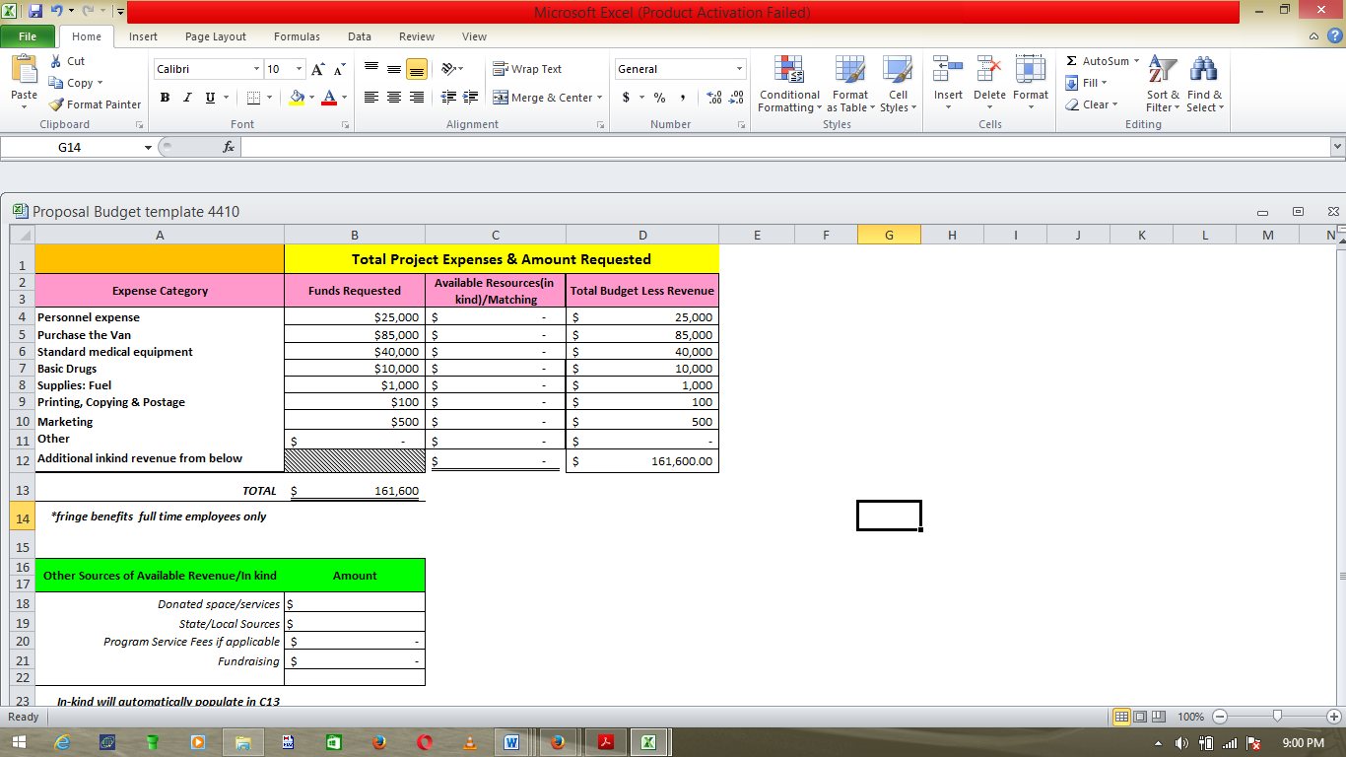
Figure 1: Budget
Time Frame: The first phase of the project is predicated to take 17 months after which continuation with the subsequent phases of the same project will be deliberated upon based on the success and effectiveness of the first phase of the project. The subsequent phases will involve duplication of this project and its wide application to other target populations. In the first month of the project, the van will be purchased following extensive market research for the best most cost-effective options and the target population will be identified. In the second month of the project, all medical equipment required to turn the van into a mobile clinic will be purchased and installed. In the following month, the basic drugs as per the needs of this population will be identified and purchased in numbers and all stocked up in the van. In the fourth month, relevant license to operate the mobile clinic will be sought and the target community sensitized on the pending project coming to their backyard. The fifth month of the project will see to it that all the required personnel to operate the clinic are contacted and the project’s official launch will be actualized 6 months after the project has been given the green light to commence. It will be carried out for a year with 2 intermittent evaluations each at 4 months post the project’s official launch as is demonstrated in the GANNT Chart below.
Project Timeline
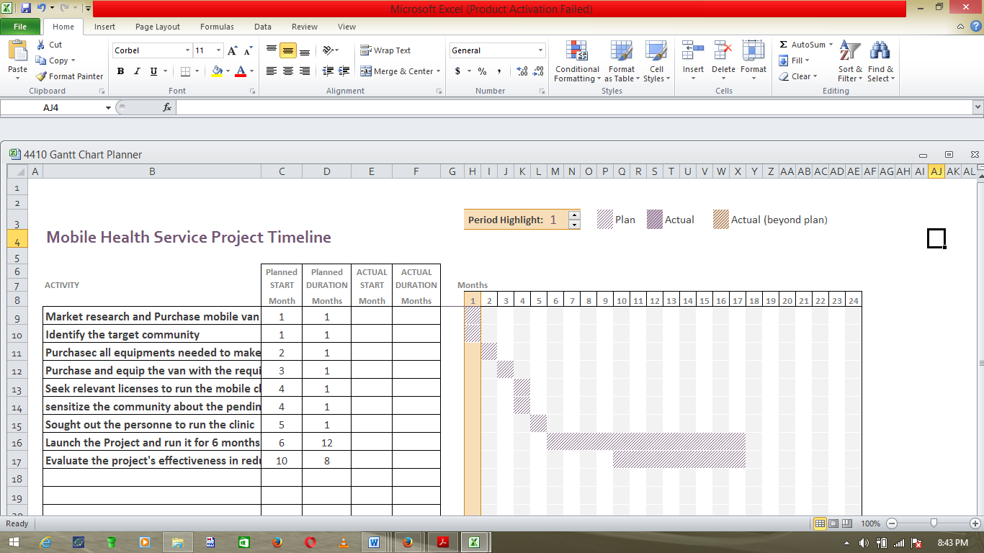
Figure 2: GANTT Chart
Return on Investment: In terms of evaluation of the results of this project, the timeframe of the project denotes two evaluation phases each four months apart. In these phases the results of the project will be evaluated for effectiveness in reducing the burden of disease in the target population. This evaluation will assume the form of surveys that will screen the community for prevalent diseases and compare these findings to those of the National Demographic and Health surveys that were conducted prior to the beginning of the project to determine any reduction in the occurrence rates and prevalence rates of the selected diseases.
Summary of Capstone Experience: I had a significant and memorable experience composing this project. I have great enjoyed the experience but most importantly, I have learned a lot on what goes into the preparation of projects proposals and the amount of practicality and logistics invested in this exercise. It is my strong belief that this Capstone Experience will leave a great mark in my experience in creating project proposal that I can effortlessly employ in a real world job scenario as I strive to actualize my role as an influential and transformation-centered healthcare leader.

References
Alotaibi, K. Y. &Federico, F. (2017). The Impact of Health Information Technology on Patient Safety. Saudi Med J., 38(12): 1173-1180
Bercovich, E. & Javitt, C. M. (2018). Medical Imaging: From Roentgen to the Digital Revolution, and Beyond. Rambam Maimonides Med J., 9(4): e0034
Swain, R. G. (2016).How does Economic and Social Disadvantage affect Health? Focus, 33(1): 1-6
Yu, Y. W. S., Hill, C., Ricks, L. M., Bennet, J., & Oriol, E. N. (2017). The Scope and Impact of Mobile Health Clinics in the United Sates: A Literature Review. Int J Equity Health, 16: 178

